TRN 01 / REQUIRED FOUNDATION

Basic Range
CADET ____________________________ CLASS ______ DATE __________
Welcome to Helios Proving Grounds. Before you command a Sol Heirs ship, show that you can send a calibration round to a known location at the assigned time.

01 Flight procedure
1. Open the matching question ID in the range.
2. Sketch displacement from the ship center to the beacon center.
3. Use GUESS in the horizontal and vertical work areas.
4. Enter signed launch velocities in m/s, then execute.
5. Replay, explain any miss, and record your result in the logbook.

02 Reference table and notation
$\overline{v} = \frac{d}{t} = \frac{v_{f} + v_{i}}{2}$
Reference: NYSED Physics Reference Tables, 2025 edition, p. 2. The endpoint-average form assumes uniform acceleration. Apply constant-acceleration equations separately to each suitable interval.
The table uses d for displacement or distance, v for velocity or speed, and t for time interval. In this manual, signed d and v preserve direction. Subscripts x and y identify vector components (table, p. 1). Map x and y are coordinates, not displacements.
$v_{x} = \frac{d_{x}}{t}\text{ ; }v_{y} = \frac{d_{y}}{t}$
Derived component form: apply the table separately along each axis. Displacement equals final coordinate minus initial coordinate. Constant velocity equals average velocity for these coasting rounds.

03 Range rules
MAP RULES Positive x is right; positive y is up. Coordinates locate centers. Ship silhouettes are schematic. The range neglects gravity, drag, and recoil. A calibration round coasts at constant velocity and is scored only at the assigned time.
The ship and beacon are stationary in Basic Range. Both components act over the same time interval. The round is a calibration marker; only its position at the check time is scored.
Complete B01-B04 for the required qualification. B05-B06 are optional. A hit is within 8 m; a precise result is within 1 m. Your instructor signs the qualification after reviewing your written reasoning.
STUDENT RANGE https://first-light-academy.inconsequent.chatgpt.site
B00 / WORKED CALIBRATION

First coordinates
Ship at (0, 0) m. Beacon at (120, 80) m. Both remain stationary. The round must reach the beacon at 4 s.
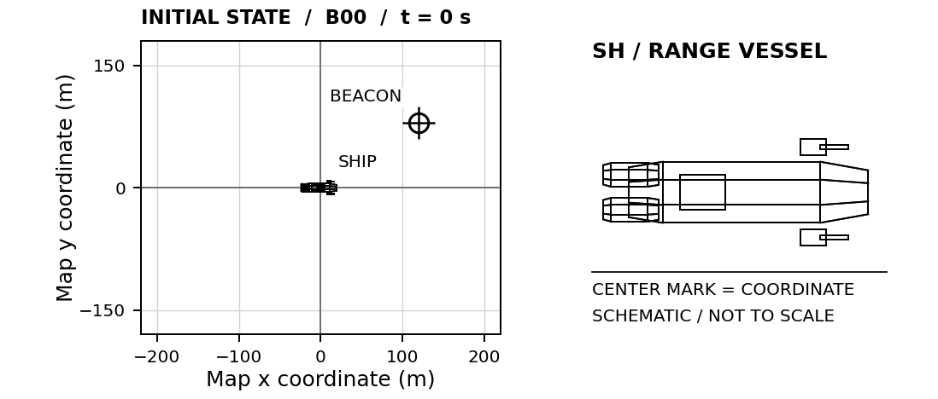

01 Horizontal calculation
$d_{x} = 120 m − 0 m = +120 m$
$v_{x} = \frac{d_{x}}{t} = \frac{120 m}{4 s}\text{ = +30 m/s}$

02 Vertical calculation
$d_{y} = 80 m − 0 m = +80 m$
$v_{y} = \frac{d_{y}}{t} = \frac{80 m}{4 s}\text{ = +20 m/s}$
ENTER IN B00 Horizontal: 30 m/s Vertical: 20 m/s
Both components describe the same round during the same 4 s. Watch the replay to see how horizontal and vertical motion occur together.

03 Before your first independent launch
A negative component means leftward or downward motion under our map convention. A zero component means no motion along that axis. Speed is a magnitude and cannot be negative.
B01 / REQUIRED FLIGHT CHECK

Port-side beacon
CADET ____________________________ CLASS ______ DATE __________
The beacon lies to the left and above your ship. Calculate both signed velocity components.
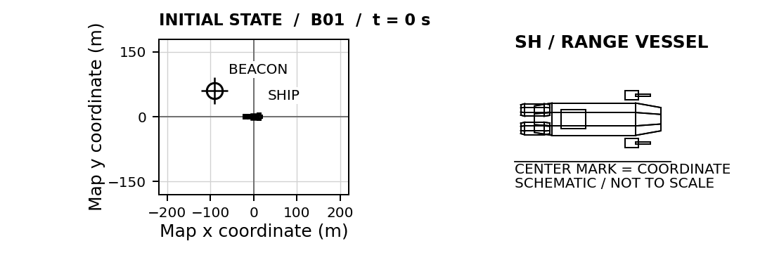
SHIP START (0, 0) m BEACON START (-90, 60) m CHECK TIME 3 s
Ship and beacon stationary. Positive x is right; positive y is up.
01 LAUNCH CALCULATION Use displacement from the ship to the final beacon position.
HORIZONTAL / x  G / U Givens and unknowns  E Equation before substitution  S / S Substitute and solve with units  $v_{x}\text{ = __________ m/s}$ | VERTICAL / y  G / U Givens and unknowns  E Equation before substitution  S / S Substitute and solve with units  $v_{y}\text{ = __________ m/s}$
SIMULATOR CHECK Best miss: ______ m □ Verified □ Retry Attempt: ______
EXPLAIN Which velocity component must be negative? Explain using the coordinates.

B02 / REQUIRED FLIGHT CHECK

Lower service gate
CADET ____________________________ CLASS ______ DATE __________
Reach the lower service gate at the assigned time. Positive y points upward on this map.
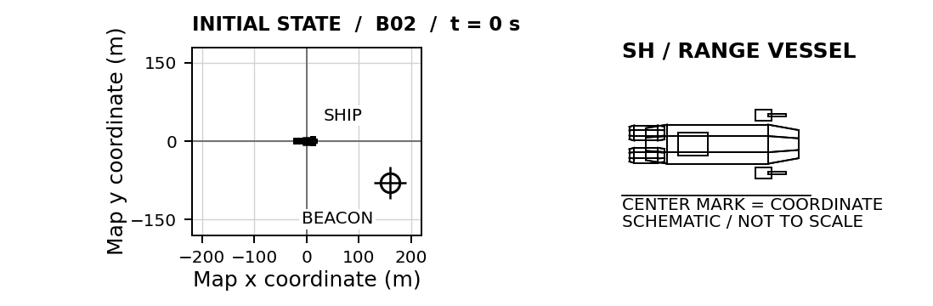
SHIP START (0, 0) m BEACON START (160, -80) m CHECK TIME 4 s
Ship and beacon stationary. Positive x is right; positive y is up.
01 LAUNCH CALCULATION Use displacement from the ship to the final beacon position.
HORIZONTAL / x  G / U Givens and unknowns  E Equation before substitution  S / S Substitute and solve with units  $v_{x}\text{ = __________ m/s}$ | VERTICAL / y  G / U Givens and unknowns  E Equation before substitution  S / S Substitute and solve with units  $v_{y}\text{ = __________ m/s}$
SIMULATOR CHECK Best miss: ______ m □ Verified □ Retry Attempt: ______
EXPLAIN A round finishes above this target. Which component should you reconsider, and why?

B03 / REQUIRED FLIGHT CHECK

Displaced launch point
CADET ____________________________ CLASS ______ DATE __________
Your ship is no longer at the origin. Find target position minus launch position before dividing by time.
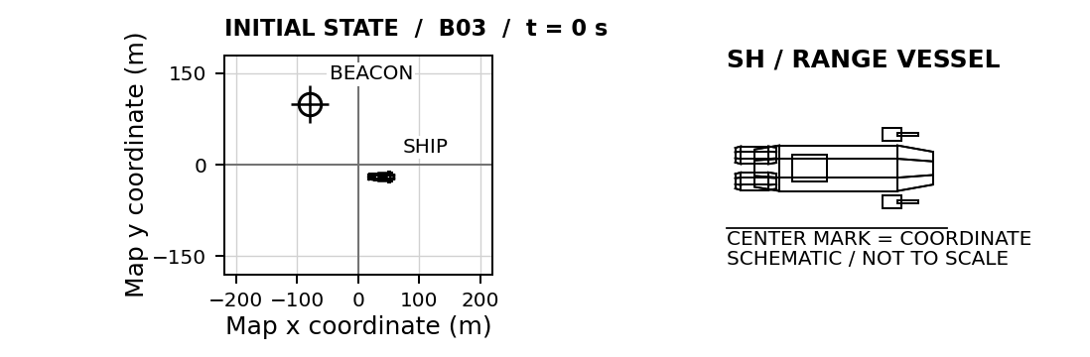
SHIP START (40, -20) m BEACON START (-80, 100) m CHECK TIME 6 s
Ship and beacon stationary. Positive x is right; positive y is up.
01 LAUNCH CALCULATION Use displacement from the ship to the final beacon position.
HORIZONTAL / x  G / U Givens and unknowns  E Equation before substitution  S / S Substitute and solve with units  $v_{x}\text{ = __________ m/s}$ | VERTICAL / y  G / U Givens and unknowns  E Equation before substitution  S / S Substitute and solve with units  $v_{y}\text{ = __________ m/s}$
SIMULATOR CHECK Best miss: ______ m □ Verified □ Retry Attempt: ______
EXPLAIN Why would dividing the target coordinates directly by time give the wrong answer?

B04 / REQUIRED FLIGHT CHECK

Range check flight
CADET ____________________________ CLASS ______ DATE __________
Complete this check flight independently. Record your equations, substitutions, and units before launching.
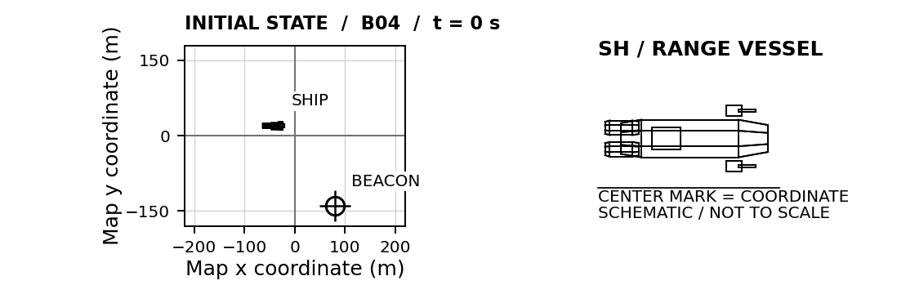
SHIP START (-40, 20) m BEACON START (80, -140) m CHECK TIME 4 s
Ship and beacon stationary. Positive x is right; positive y is up.
01 LAUNCH CALCULATION Use displacement from the ship to the final beacon position.
HORIZONTAL / x  G / U Givens and unknowns  E Equation before substitution  S / S Substitute and solve with units  $v_{x}\text{ = __________ m/s}$ | VERTICAL / y  G / U Givens and unknowns  E Equation before substitution  S / S Substitute and solve with units  $v_{y}\text{ = __________ m/s}$
SIMULATOR CHECK Best miss: ______ m □ Verified □ Retry Attempt: ______
EXPLAIN If the check time doubled, how would both required velocity components change? Explain.

B05 / OPTIONAL PRECISION PRACTICE

Precision extension
CADET ____________________________ CLASS ______ DATE __________
An optional longer-duration calibration. The equations and units remain the same.
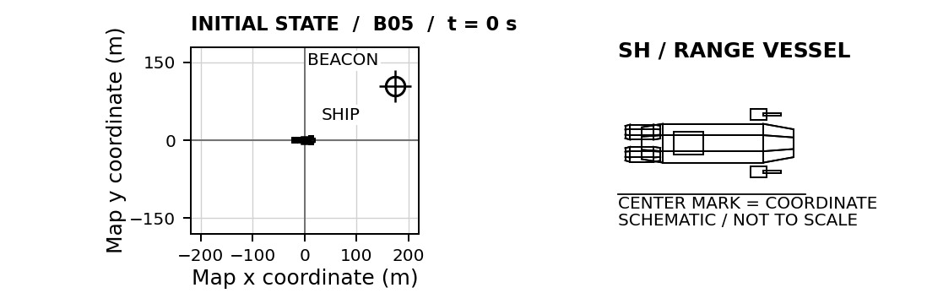
SHIP START (0, 0) m BEACON START (175, 105) m CHECK TIME 7 s
Ship and beacon stationary. Positive x is right; positive y is up.
01 LAUNCH CALCULATION Use displacement from the ship to the final beacon position.
HORIZONTAL / x  G / U Givens and unknowns  E Equation before substitution  S / S Substitute and solve with units  $v_{x}\text{ = __________ m/s}$ | VERTICAL / y  G / U Givens and unknowns  E Equation before substitution  S / S Substitute and solve with units  $v_{y}\text{ = __________ m/s}$
SIMULATOR CHECK Best miss: ______ m □ Verified □ Retry Attempt: ______
EXPLAIN Why does a small velocity error matter more over a longer flight?

B06 / OPTIONAL PRECISION PRACTICE

Decimal precision
CADET ____________________________ CLASS ______ DATE __________
Keep enough decimal places to reach the center. Do not round your components to whole numbers.
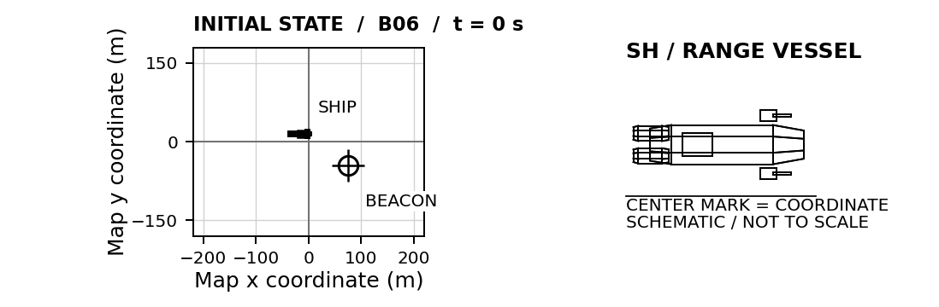
SHIP START (-15, 15) m BEACON START (75, -45) m CHECK TIME 8 s
Ship and beacon stationary. Positive x is right; positive y is up.
01 LAUNCH CALCULATION Use displacement from the ship to the final beacon position.
HORIZONTAL / x  G / U Givens and unknowns  E Equation before substitution  S / S Substitute and solve with units  $v_{x}\text{ = __________ m/s}$ | VERTICAL / y  G / U Givens and unknowns  E Equation before substitution  S / S Substitute and solve with units  $v_{y}\text{ = __________ m/s}$
SIMULATOR CHECK Best miss: ______ m □ Verified □ Retry Attempt: ______
EXPLAIN Explain why 11 m/s horizontally produces a different endpoint from 11.25 m/s after 8 s.

