SPC 01 / OPTIONAL CERTIFICATION

Dead Reckoning
CADET ____________________________ CLASS ______ DATE __________
A moving ship contributes its velocity to every round it launches. Earn this specialty by calculating the launch settings needed while the ship is already drifting. Basic Range is the prerequisite.

01 Reference table
$\overline{v} = \frac{d}{t} = \frac{v_{f} + v_{i}}{2}$
Reference: NYSED Physics Reference Tables, 2025 edition, p. 2. The endpoint-average form assumes uniform acceleration. Apply constant-acceleration equations separately to each suitable interval.
The table uses d for displacement or distance, v for velocity or speed, and t for time interval. In this manual, signed d and v preserve direction. Subscripts x and y identify vector components (table, p. 1). Map x and y are coordinates, not displacements.

02 Name the reference frame
Quantity | Meaning
Round map velocity | Round motion measured against the fixed map grid.
Ship map velocity | Ship motion measured against the same grid.
Launch velocity relative to ship | Round motion relative to the launcher. These are the console inputs.
Derived relative-motion rule, applied separately along each axis:
Round map velocity = ship map velocity + launch velocity relative to ship
Rearrange to find the console setting: required round map velocity minus ship map velocity. Labels identify each frame; the variable remains v.

03 Plan the interception
1. Predict the beacon’s coordinates at the check time.
2. Find displacement from the ship’s position at launch.
3. Divide each displacement component by the flight time.
4. Subtract the corresponding ship-velocity component.
5. Check by adding the ship velocity back exactly once.
Launch occurs at t = 0 s. Do not replace the launch position with the ship’s future position. The round separates from the ship and then coasts.
Complete D01-D03 for instructor review. D03 also requires a predicted beacon position. This optional specialty does not replace Motion Graphs.
D00 / WORKED EXAMPLE

A moving launch platform
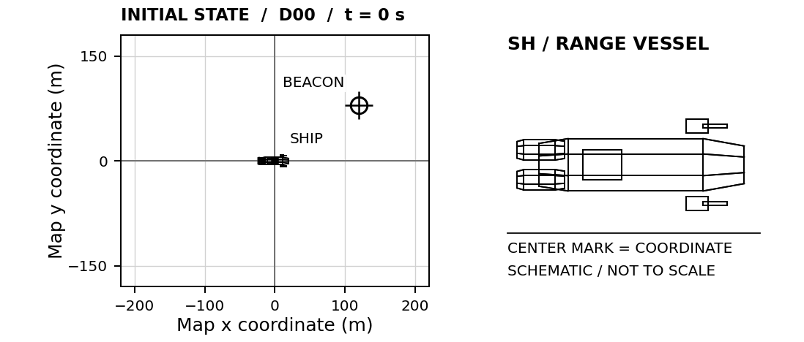
Ship at (0, 0) m with map velocity (10, −5) m/s. Stationary beacon at (120, 80) m. Check time: 4 s.

01 Required round map velocity
$v_{x} = \frac{120 m}{4 s}\text{ = 30 m/s ; }v_{y} = \frac{80 m}{4 s}\text{ = 20 m/s}$

02 Launch velocity relative to the ship
$v_{x}\text{ = 30 m/s − 10 m/s = 20 m/s}$
$v_{y}\text{ = 20 m/s − (−5 m/s) = 25 m/s}$
ENTER IN D00 Horizontal: 20 m/s Vertical: 25 m/s
Check the map frame: (20 + 10, 25 − 5) = (30, 20) m/s. After 4 s the round reaches (120, 80) m; the ship is at (40, −20) m.

03 Before the next check
Why is the vertical launcher setting greater than the round’s required vertical map velocity?

D01 / OPTIONAL SPECIALTY

Following current
CADET ____________________________ CLASS ______ DATE __________
Your ship coasts toward the beacon. Enter velocity relative to the ship; the simulator adds the ship's velocity once.
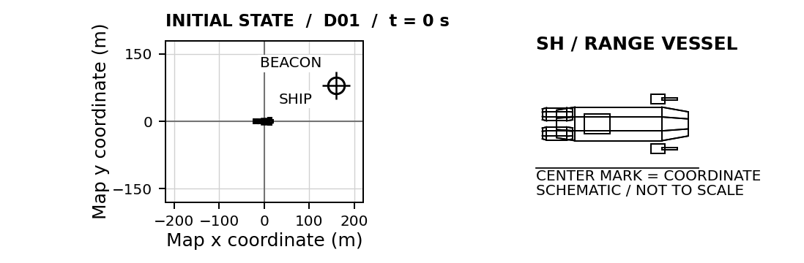
SHIP START (0, 0) m BEACON START (160, 80) m CHECK TIME 4 s
Ship map velocity (10, 0) m/s. Beacon map velocity (0, 0) m/s.
01 LAUNCH CALCULATION Find round map velocity, then subtract ship map velocity.
HORIZONTAL / x  G / U Givens and unknowns  E Equation before substitution  S / S Substitute and solve with units  $v_{x}\text{ = __________ m/s}$ | VERTICAL / y  G / U Givens and unknowns  E Equation before substitution  S / S Substitute and solve with units  $v_{y}\text{ = __________ m/s}$
SIMULATOR CHECK Best miss: ______ m □ Verified □ Retry Attempt: ______
EXPLAIN How much horizontal map velocity does the ship contribute to the round?

D02 / OPTIONAL SPECIALTY

Crossing drift
CADET ____________________________ CLASS ______ DATE __________
Account for the ship's nonzero starting position and its motion along both axes. The launch occurs at t = 0 s.
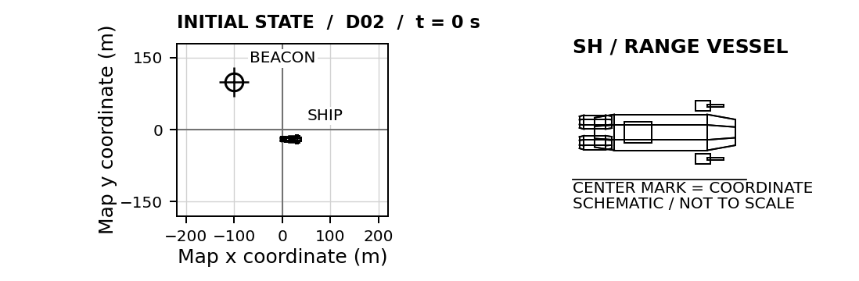
SHIP START (20, -20) m BEACON START (-100, 100) m CHECK TIME 6 s
Ship map velocity (-5, 10) m/s. Beacon map velocity (0, 0) m/s.
01 LAUNCH CALCULATION Find round map velocity, then subtract ship map velocity.
HORIZONTAL / x  G / U Givens and unknowns  E Equation before substitution  S / S Substitute and solve with units  $v_{x}\text{ = __________ m/s}$ | VERTICAL / y  G / U Givens and unknowns  E Equation before substitution  S / S Substitute and solve with units  $v_{y}\text{ = __________ m/s}$
SIMULATOR CHECK Best miss: ______ m □ Verified □ Retry Attempt: ______
EXPLAIN Explain the distinction between the round's map velocity and its launch velocity relative to the ship.

D03 / OPTIONAL SPECIALTY

Two moving vessels
CADET ____________________________ CLASS ______ DATE __________
Predict the moving beacon's coordinates at 5 s. Enter your prediction to place its ghost marker, then calculate the launcher settings. The ghost shows your prediction only.
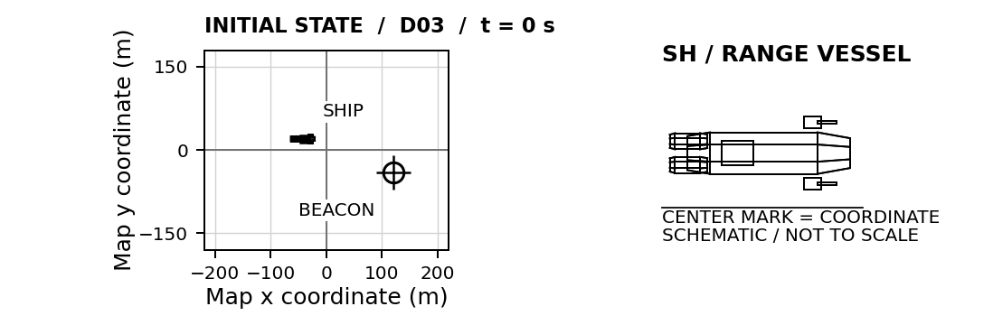
SHIP START (-40, 20) m BEACON START (120, -40) m CHECK TIME 5 s
Ship map velocity (8, -6) m/s. Beacon map velocity (-2, 4) m/s.
PREDICTED BEACON AT CHECK TIME (__________, __________) m
01 LAUNCH CALCULATION Find round map velocity, then subtract ship map velocity.
HORIZONTAL / x  G / U Givens and unknowns  E Equation before substitution  S / S Substitute and solve with units  $v_{x}\text{ = __________ m/s}$ | VERTICAL / y  G / U Givens and unknowns  E Equation before substitution  S / S Substitute and solve with units  $v_{y}\text{ = __________ m/s}$
SIMULATOR CHECK Best miss: ______ m □ Verified □ Retry Attempt: ______
EXPLAIN Explain why aiming at the beacon's initial position fails, even with the correct ship-velocity correction.

