SOL HEIRS / FLIGHT OPERATIONS

First Light Academy
HELIOS PROVING GROUNDS

CADET FLIGHT MANUAL
MOTION • NAVIGATION • RANGE QUALIFICATION

ISSUED TO ______________________________________________________
CLASS / SECTION __________________ CALLSIGN __________________
ISSUE DATE ________________________ INSTRUCTOR _______________
Required foundation: Basic Range and Motion Graphs
Optional specialty: Dead Reckoning
Calculate on paper. Test in the range. Record what happened.
LOG 01 / QUALIFICATION RECORD

Pilot Logbook
CADET ____________________________ CLASS ______ DATE __________
Record precise results and keep the calculations in your manual. Your instructor reviews written reasoning before signing each qualification.
Flight check | Miss in m | Verified | Date
B01 / Port-side beacon
B02 / Lower service gate
B03 / Displaced launch point
B04 / Range check flight
G01 / A descending trace
G02 / Area is a journey
G03 / Reversal protocol
G04 / An accelerating contact
G05 / From acceleration to position
D01 / Following current
D02 / Crossing drift
D03 / Two moving vessels
Verified: launch endpoint within 1 m. Every G check and D03 also need a beacon prediction within 1 m. G checks need the graph reading within 0.05 of the required value. B05-B06 are optional practice.

01 Certification board
Qualification | Evidence | Instructor and date
Basic Range / required | B01-B04 and written work
Motion Graphs / required | G01-G05 and written work
Dead Reckoning / optional | D01-D03 and written work
Future certifications: Maneuvering, advanced weapons, and fleet operations. Full Flight Wings will also require the planned maneuvering course.
NEXT OBJECTIVE __________________________________________________
Before you leave: export the digital logbook so you can continue on another device.
TRN 01 / REQUIRED FOUNDATION

Basic Range
CADET ____________________________ CLASS ______ DATE __________
Welcome to Helios Proving Grounds. Before you command a Sol Heirs ship, show that you can send a calibration round to a known location at the assigned time.

01 Flight procedure
1. Open the matching question ID in the range.
2. Sketch displacement from the ship center to the beacon center.
3. Use GUESS in the horizontal and vertical work areas.
4. Enter signed launch velocities in m/s, then execute.
5. Replay, explain any miss, and record your result in the logbook.

02 Reference table and notation
$\overline{v} = \frac{d}{t} = \frac{v_{f} + v_{i}}{2}$
Reference: NYSED Physics Reference Tables, 2025 edition, p. 2. The endpoint-average form assumes uniform acceleration. Apply constant-acceleration equations separately to each suitable interval.
The table uses d for displacement or distance, v for velocity or speed, and t for time interval. In this manual, signed d and v preserve direction. Subscripts x and y identify vector components (table, p. 1). Map x and y are coordinates, not displacements.
$v_{x} = \frac{d_{x}}{t}\text{ ; }v_{y} = \frac{d_{y}}{t}$
Derived component form: apply the table separately along each axis. Displacement equals final coordinate minus initial coordinate. Constant velocity equals average velocity for these coasting rounds.

03 Range rules
MAP RULES Positive x is right; positive y is up. Coordinates locate centers. Ship silhouettes are schematic. The range neglects gravity, drag, and recoil. A calibration round coasts at constant velocity and is scored only at the assigned time.
The ship and beacon are stationary in Basic Range. Both components act over the same time interval. The round is a calibration marker; only its position at the check time is scored.
Complete B01-B04 for the required qualification. B05-B06 are optional. A hit is within 8 m; a precise result is within 1 m. Your instructor signs the qualification after reviewing your written reasoning.
STUDENT RANGE https://first-light-academy.inconsequent.chatgpt.site
B00 / WORKED CALIBRATION

First coordinates
Ship at (0, 0) m. Beacon at (120, 80) m. Both remain stationary. The round must reach the beacon at 4 s.
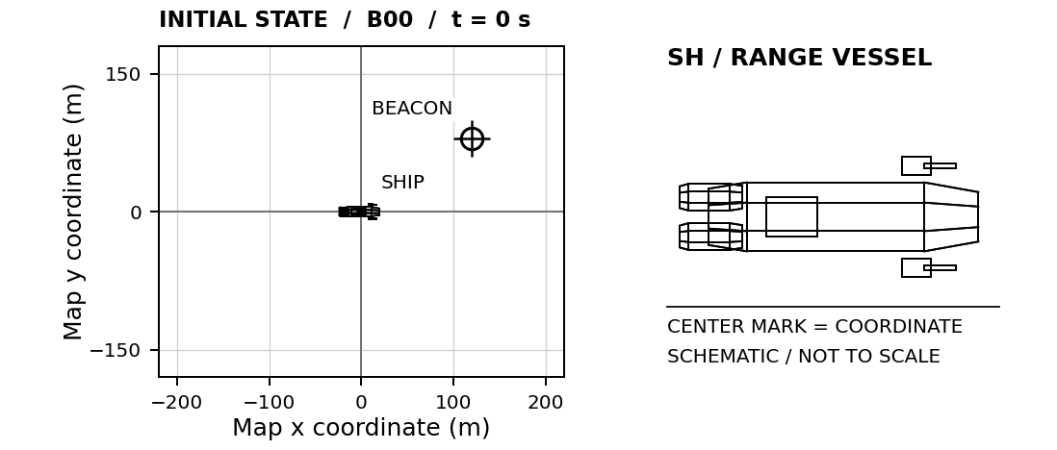

01 Horizontal calculation
$d_{x} = 120 m − 0 m = +120 m$
$v_{x} = \frac{d_{x}}{t} = \frac{120 m}{4 s}\text{ = +30 m/s}$

02 Vertical calculation
$d_{y} = 80 m − 0 m = +80 m$
$v_{y} = \frac{d_{y}}{t} = \frac{80 m}{4 s}\text{ = +20 m/s}$
ENTER IN B00 Horizontal: 30 m/s Vertical: 20 m/s
Both components describe the same round during the same 4 s. Watch the replay to see how horizontal and vertical motion occur together.

03 Before your first independent launch
A negative component means leftward or downward motion under our map convention. A zero component means no motion along that axis. Speed is a magnitude and cannot be negative.
B01 / REQUIRED FLIGHT CHECK

Port-side beacon
CADET ____________________________ CLASS ______ DATE __________
The beacon lies to the left and above your ship. Calculate both signed velocity components.
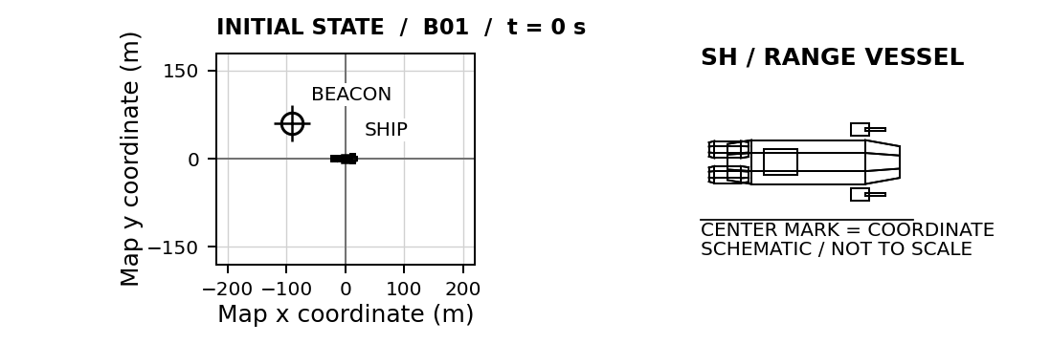
SHIP START (0, 0) m BEACON START (-90, 60) m CHECK TIME 3 s
Ship and beacon stationary. Positive x is right; positive y is up.
01 LAUNCH CALCULATION Use displacement from the ship to the final beacon position.
HORIZONTAL / x  G / U Givens and unknowns  E Equation before substitution  S / S Substitute and solve with units  $v_{x}\text{ = __________ m/s}$ | VERTICAL / y  G / U Givens and unknowns  E Equation before substitution  S / S Substitute and solve with units  $v_{y}\text{ = __________ m/s}$
SIMULATOR CHECK Best miss: ______ m □ Verified □ Retry Attempt: ______
EXPLAIN Which velocity component must be negative? Explain using the coordinates.

B02 / REQUIRED FLIGHT CHECK

Lower service gate
CADET ____________________________ CLASS ______ DATE __________
Reach the lower service gate at the assigned time. Positive y points upward on this map.
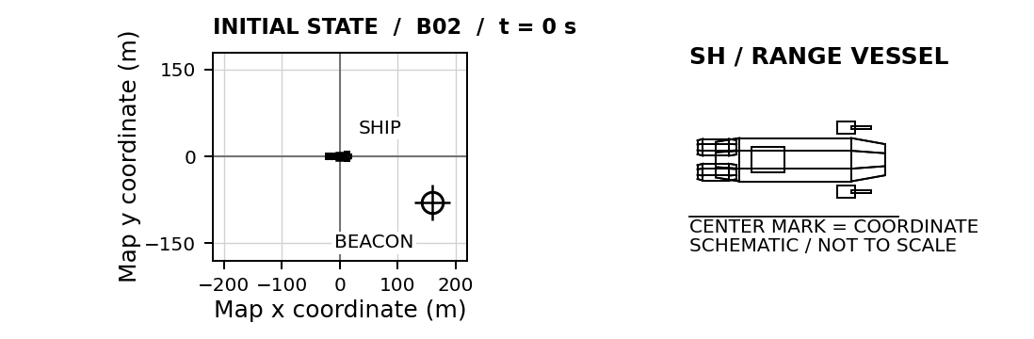
SHIP START (0, 0) m BEACON START (160, -80) m CHECK TIME 4 s
Ship and beacon stationary. Positive x is right; positive y is up.
01 LAUNCH CALCULATION Use displacement from the ship to the final beacon position.
HORIZONTAL / x  G / U Givens and unknowns  E Equation before substitution  S / S Substitute and solve with units  $v_{x}\text{ = __________ m/s}$ | VERTICAL / y  G / U Givens and unknowns  E Equation before substitution  S / S Substitute and solve with units  $v_{y}\text{ = __________ m/s}$
SIMULATOR CHECK Best miss: ______ m □ Verified □ Retry Attempt: ______
EXPLAIN A round finishes above this target. Which component should you reconsider, and why?

B03 / REQUIRED FLIGHT CHECK

Displaced launch point
CADET ____________________________ CLASS ______ DATE __________
Your ship is no longer at the origin. Find target position minus launch position before dividing by time.
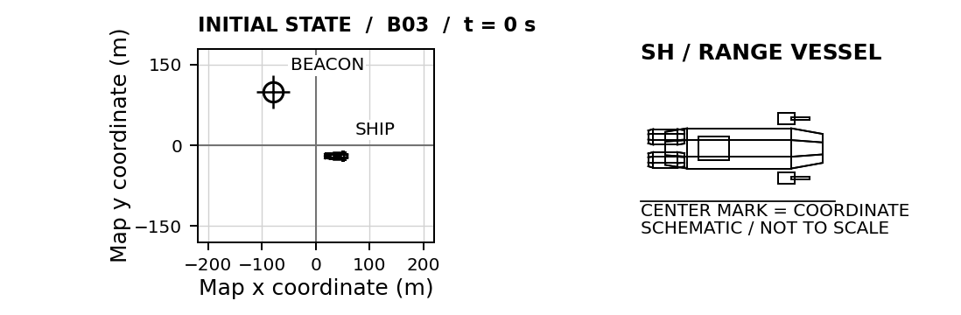
SHIP START (40, -20) m BEACON START (-80, 100) m CHECK TIME 6 s
Ship and beacon stationary. Positive x is right; positive y is up.
01 LAUNCH CALCULATION Use displacement from the ship to the final beacon position.
HORIZONTAL / x  G / U Givens and unknowns  E Equation before substitution  S / S Substitute and solve with units  $v_{x}\text{ = __________ m/s}$ | VERTICAL / y  G / U Givens and unknowns  E Equation before substitution  S / S Substitute and solve with units  $v_{y}\text{ = __________ m/s}$
SIMULATOR CHECK Best miss: ______ m □ Verified □ Retry Attempt: ______
EXPLAIN Why would dividing the target coordinates directly by time give the wrong answer?

B04 / REQUIRED FLIGHT CHECK

Range check flight
CADET ____________________________ CLASS ______ DATE __________
Complete this check flight independently. Record your equations, substitutions, and units before launching.
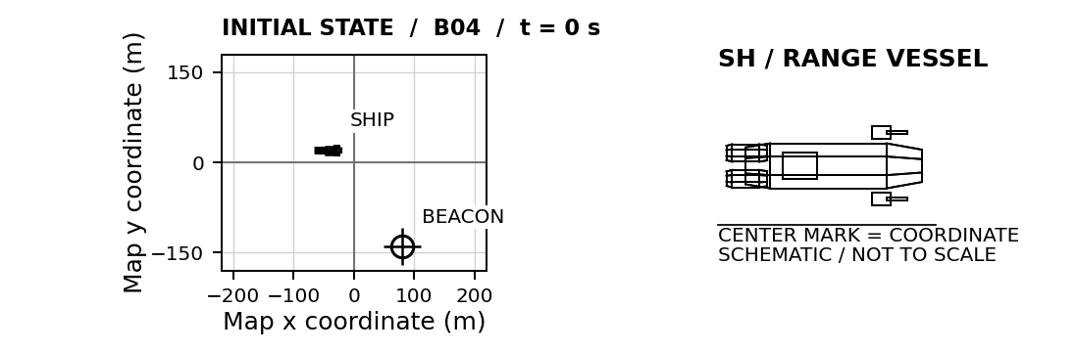
SHIP START (-40, 20) m BEACON START (80, -140) m CHECK TIME 4 s
Ship and beacon stationary. Positive x is right; positive y is up.
01 LAUNCH CALCULATION Use displacement from the ship to the final beacon position.
HORIZONTAL / x  G / U Givens and unknowns  E Equation before substitution  S / S Substitute and solve with units  $v_{x}\text{ = __________ m/s}$ | VERTICAL / y  G / U Givens and unknowns  E Equation before substitution  S / S Substitute and solve with units  $v_{y}\text{ = __________ m/s}$
SIMULATOR CHECK Best miss: ______ m □ Verified □ Retry Attempt: ______
EXPLAIN If the check time doubled, how would both required velocity components change? Explain.

B05 / OPTIONAL PRECISION PRACTICE

Precision extension
CADET ____________________________ CLASS ______ DATE __________
An optional longer-duration calibration. The equations and units remain the same.
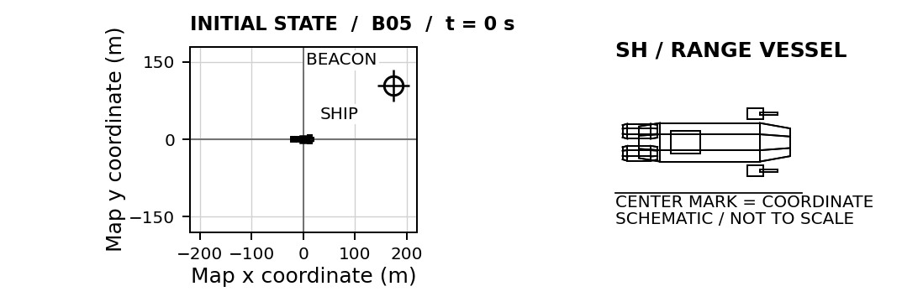
SHIP START (0, 0) m BEACON START (175, 105) m CHECK TIME 7 s
Ship and beacon stationary. Positive x is right; positive y is up.
01 LAUNCH CALCULATION Use displacement from the ship to the final beacon position.
HORIZONTAL / x  G / U Givens and unknowns  E Equation before substitution  S / S Substitute and solve with units  $v_{x}\text{ = __________ m/s}$ | VERTICAL / y  G / U Givens and unknowns  E Equation before substitution  S / S Substitute and solve with units  $v_{y}\text{ = __________ m/s}$
SIMULATOR CHECK Best miss: ______ m □ Verified □ Retry Attempt: ______
EXPLAIN Why does a small velocity error matter more over a longer flight?

B06 / OPTIONAL PRECISION PRACTICE

Decimal precision
CADET ____________________________ CLASS ______ DATE __________
Keep enough decimal places to reach the center. Do not round your components to whole numbers.
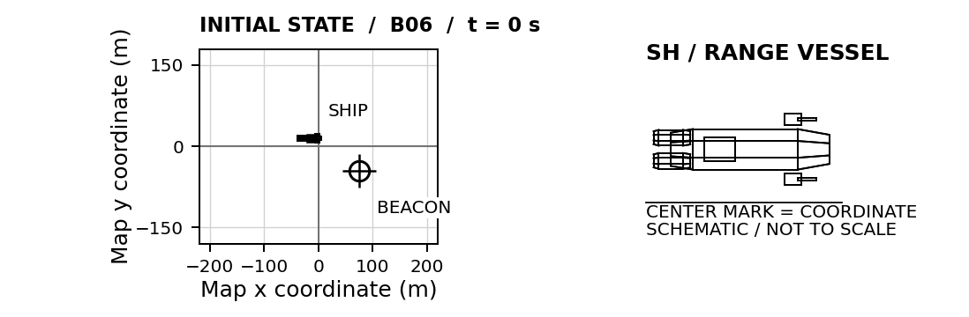
SHIP START (-15, 15) m BEACON START (75, -45) m CHECK TIME 8 s
Ship and beacon stationary. Positive x is right; positive y is up.
01 LAUNCH CALCULATION Use displacement from the ship to the final beacon position.
HORIZONTAL / x  G / U Givens and unknowns  E Equation before substitution  S / S Substitute and solve with units  $v_{x}\text{ = __________ m/s}$ | VERTICAL / y  G / U Givens and unknowns  E Equation before substitution  S / S Substitute and solve with units  $v_{y}\text{ = __________ m/s}$
SIMULATOR CHECK Best miss: ______ m □ Verified □ Retry Attempt: ______
EXPLAIN Explain why 11 m/s horizontally produces a different endpoint from 11.25 m/s after 8 s.

TRN 02 / REQUIRED CERTIFICATION

Motion Graphs
CADET ____________________________ CLASS ______ DATE __________
A moving beacon sends a motion trace to your console. Interpret the graph, predict its position at the check time, then calculate a round that meets it there. Complete Basic Range first.

01 Reference table equations
$\overline{v} = \frac{d}{t} = \frac{v_{f} + v_{i}}{2}$
$a = \frac{Δv}{t} = \frac{v_{f} − v_{i}}{t}$
$v_{f} = v_{i} + at$
$d = v_{i}t + \frac{1}{2}at^{2}$
Reference: NYSED Physics Reference Tables, 2025 edition, p. 2. The endpoint-average form assumes uniform acceleration. Apply constant-acceleration equations separately to each suitable interval.
The bar means average. Subscripts i and f mean initial and final. Δ means change. The added x and y subscripts identify components. Graphs show only the beacon’s horizontal motion.

02 Read the axes before calculating
Graph | Slope | Signed area
Displacement vs time | Velocity | Not used here
Velocity vs time | Acceleration | Displacement
Acceleration vs time | Not used here | Change in velocity
These graph rules are derived relationships. A horizontal displacement-time line means rest. A horizontal velocity-time line means constant velocity, which may be nonzero.
Area below zero on a velocity-time graph is negative displacement. Add area magnitudes to obtain total distance. On an acceleration-time graph, area gives a change in velocity, not displacement.

03 Qualification sequence
G01: slope and direction. G02: signed area. G03: distance and displacement. G04: acceleration and reversal. G05: acceleration to velocity to position.
For every G check, enter the requested graph reading, predicted beacon coordinates, and round launch velocities. The prediction marker displays your estimate. It does not reveal the correct answer.
Use the table of graph points in the console when needed. Read, calculate, then test. The ship and round do not accelerate in this course.
G00 / WORKED TELEMETRY CHECK

Reading the trace
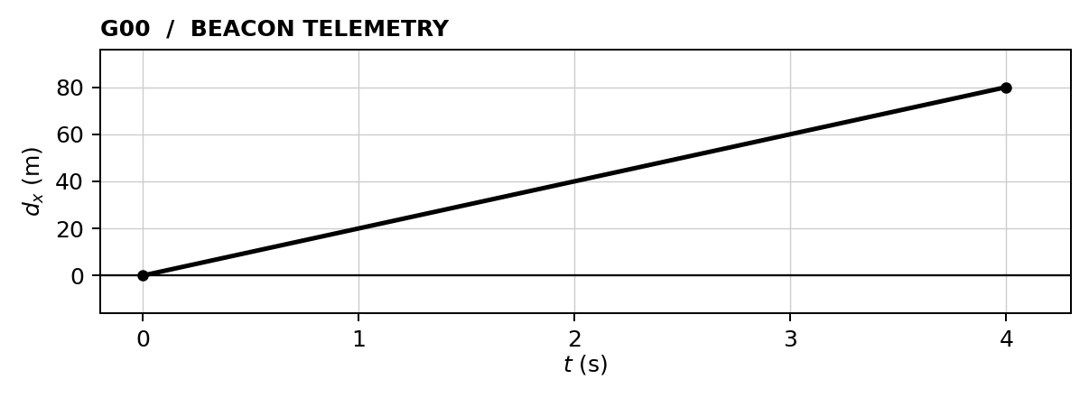
The ship starts at (0, 0) m. The beacon starts at (40, 40) m. Its displacement is measured from its own starting point, so the graph begins at zero.

01 Read the beacon velocity and displacement
$v_{x} = \frac{80 m − 0 m}{4 s − 0 s}\text{ = +20 m/s (beacon)}$
The beacon moves +80 m horizontally in 4 s. Final beacon coordinates: (40 + 80, 40) = (120, 40) m. Its vertical coordinate stays fixed.

02 Calculate the round velocity
$v_{x} = \frac{120 m − 0 m}{4 s}\text{ = +30 m/s}$
$v_{y} = \frac{40 m − 0 m}{4 s}\text{ = +10 m/s}$
ENTER IN G00 Graph reading: 20 m/s
Beacon prediction: (120, 40) m Launcher: (30, 10) m/s

03 Read a flat trace
Quick paper check: If a displacement-time trace stays at +20 m from 2 s to 5 s, what is the velocity during that interval? Explain without dividing the graph height by the elapsed time.

G01 / REQUIRED FLIGHT CHECK

A descending trace
CADET ____________________________ CLASS ______ DATE __________
Read the slope of the displacement–time graph. Find the beacon’s signed horizontal velocity, predict its coordinates at 4 s, and intercept it. Vertical motion is zero.
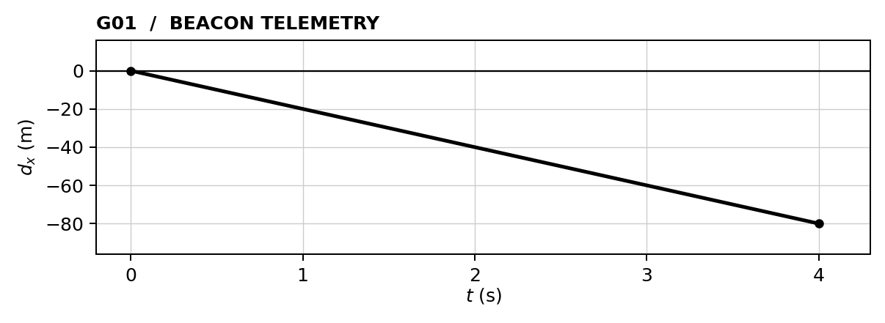
SHIP START (0, 0) m BEACON START (160, 80) m CHECK TIME 4 s
Ship stationary. Beacon moves horizontally only; its y coordinate stays fixed.
01 GRAPH READING Horizontal beacon velocity = __________ m/s
Show the slope or area calculation. Then find signed horizontal displacement.

$d_{x}\text{ = ______ m (beacon)}$
PREDICTED BEACON AT CHECK TIME (__________, __________) m
02 LAUNCH CALCULATION Use displacement from the ship to the final beacon position.
HORIZONTAL / x  G / U Givens and unknowns  E Equation before substitution  S / S Substitute and solve with units  $v_{x}\text{ = __________ m/s}$ | VERTICAL / y  G / U Givens and unknowns  E Equation before substitution  S / S Substitute and solve with units  $v_{y}\text{ = __________ m/s}$
SIMULATOR CHECK Best miss: ______ m □ Verified □ Retry Attempt: ______
EXPLAIN What does a downward-sloping displacement–time line tell you about direction?

G02 / REQUIRED FLIGHT CHECK

Area is a journey
CADET ____________________________ CLASS ______ DATE __________
Read the area under the velocity–time graph from 0 to 6 s. Add that displacement to the beacon’s initial x coordinate. Its y coordinate stays fixed.
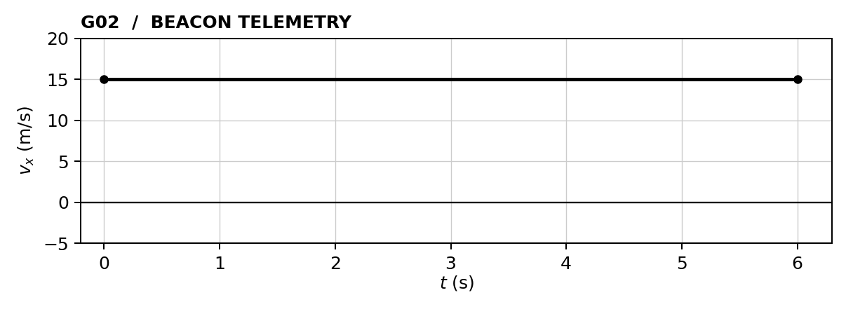
SHIP START (0, 0) m BEACON START (-60, 60) m CHECK TIME 6 s
Ship stationary. Beacon moves horizontally only; its y coordinate stays fixed.
01 GRAPH READING Horizontal beacon displacement = __________ m
Show the slope or area calculation. Then find signed horizontal displacement.

$d_{x}\text{ = ______ m (beacon)}$
PREDICTED BEACON AT CHECK TIME (__________, __________) m
02 LAUNCH CALCULATION Use displacement from the ship to the final beacon position.
HORIZONTAL / x  G / U Givens and unknowns  E Equation before substitution  S / S Substitute and solve with units  $v_{x}\text{ = __________ m/s}$ | VERTICAL / y  G / U Givens and unknowns  E Equation before substitution  S / S Substitute and solve with units  $v_{y}\text{ = __________ m/s}$
SIMULATOR CHECK Best miss: ______ m □ Verified □ Retry Attempt: ______
EXPLAIN Why does the area under this graph have units of meters rather than meters per second?

G03 / REQUIRED FLIGHT CHECK

Reversal protocol
CADET ____________________________ CLASS ______ DATE __________
The beacon reverses at 3 s. Find its total distance traveled, then use signed displacement to predict its final position. The instantaneous velocity change is an idealized training maneuver.
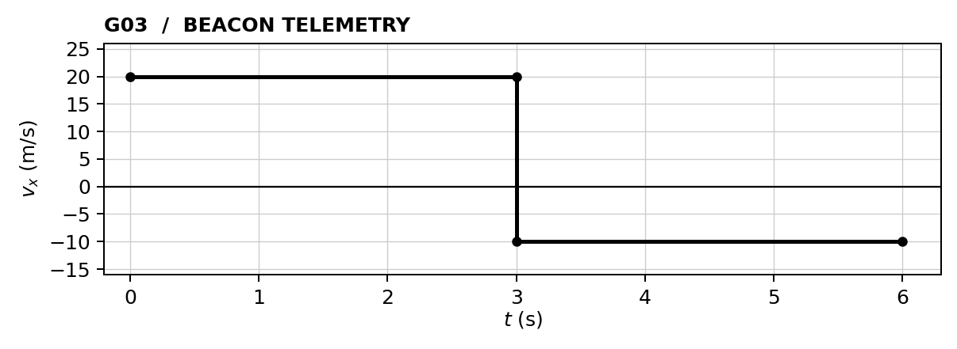
SHIP START (0, 0) m BEACON START (60, -60) m CHECK TIME 6 s
Ship stationary. Beacon moves horizontally only; its y coordinate stays fixed.
01 GRAPH READING Total horizontal distance traveled = __________ m
Show the slope or area calculation. Then find signed horizontal displacement.

$d_{x}\text{ = ______ m (beacon)}$
PREDICTED BEACON AT CHECK TIME (__________, __________) m
02 LAUNCH CALCULATION Use displacement from the ship to the final beacon position.
HORIZONTAL / x  G / U Givens and unknowns  E Equation before substitution  S / S Substitute and solve with units  $v_{x}\text{ = __________ m/s}$ | VERTICAL / y  G / U Givens and unknowns  E Equation before substitution  S / S Substitute and solve with units  $v_{y}\text{ = __________ m/s}$
SIMULATOR CHECK Best miss: ______ m □ Verified □ Retry Attempt: ______
EXPLAIN Explain why the total distance traveled is greater than the magnitude of the displacement.

G04 / REQUIRED FLIGHT CHECK

An accelerating contact
CADET ____________________________ CLASS ______ DATE __________
The beacon accelerates uniformly. Read acceleration from the slope and displacement from signed area. Predict the beacon’s position at 4 s. The launched round still coasts at constant velocity.
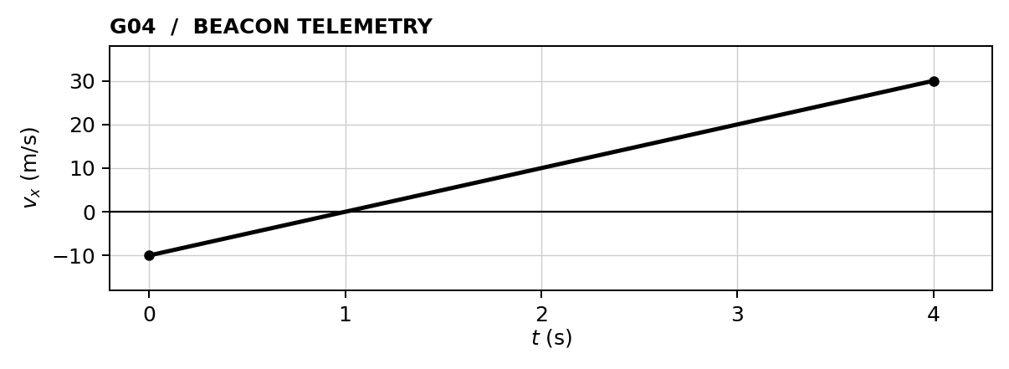
SHIP START (0, 0) m BEACON START (80, 80) m CHECK TIME 4 s
Ship stationary. Beacon moves horizontally only; its y coordinate stays fixed.
01 GRAPH READING Horizontal beacon acceleration = __________ m/s²
Show the slope or area calculation. Then find signed horizontal displacement.

$d_{x}\text{ = ______ m (beacon)}$
PREDICTED BEACON AT CHECK TIME (__________, __________) m
02 LAUNCH CALCULATION Use displacement from the ship to the final beacon position.
HORIZONTAL / x  G / U Givens and unknowns  E Equation before substitution  S / S Substitute and solve with units  $v_{x}\text{ = __________ m/s}$ | VERTICAL / y  G / U Givens and unknowns  E Equation before substitution  S / S Substitute and solve with units  $v_{y}\text{ = __________ m/s}$
SIMULATOR CHECK Best miss: ______ m □ Verified □ Retry Attempt: ______
EXPLAIN When does the beacon reverse direction? Why is the area below zero subtracted?

G05 / REQUIRED FLIGHT CHECK

From acceleration to position
CADET ____________________________ CLASS ______ DATE __________
The beacon’s initial horizontal velocity is +10 m/s. Use the acceleration graph to find its final velocity and displacement over 4 s. Its vertical velocity is zero.
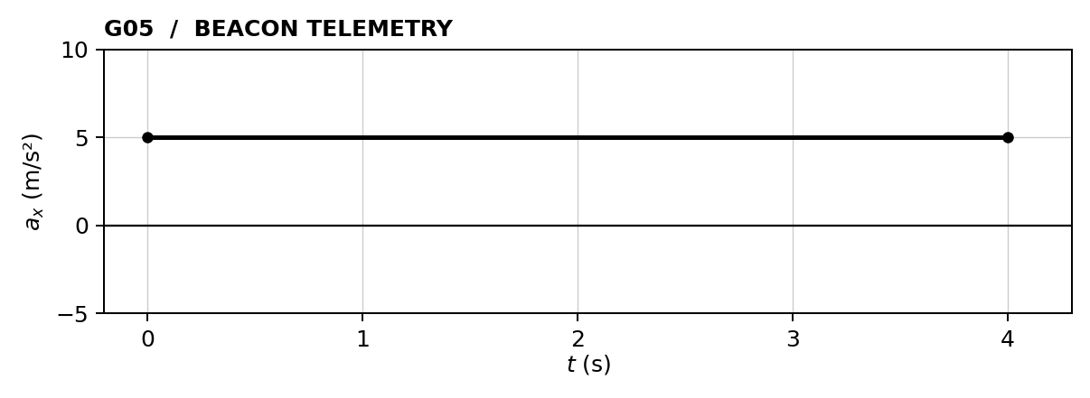
SHIP START (0, 0) m BEACON START (-80, 60) m CHECK TIME 4 s
Ship stationary. Beacon moves horizontally only; its y coordinate stays fixed.
01 GRAPH READING Final horizontal beacon velocity = __________ m/s
Show the slope or area calculation. Then find signed horizontal displacement.

$d_{x}\text{ = ______ m (beacon)}$
PREDICTED BEACON AT CHECK TIME (__________, __________) m
02 LAUNCH CALCULATION Use displacement from the ship to the final beacon position.
HORIZONTAL / x  G / U Givens and unknowns  E Equation before substitution  S / S Substitute and solve with units  $v_{x}\text{ = __________ m/s}$ | VERTICAL / y  G / U Givens and unknowns  E Equation before substitution  S / S Substitute and solve with units  $v_{y}\text{ = __________ m/s}$
SIMULATOR CHECK Best miss: ______ m □ Verified □ Retry Attempt: ______
EXPLAIN What does the area under an acceleration–time graph give you? How do you then find displacement?

SPC 01 / OPTIONAL CERTIFICATION

Dead Reckoning
CADET ____________________________ CLASS ______ DATE __________
A moving ship contributes its velocity to every round it launches. Earn this specialty by calculating the launch settings needed while the ship is already drifting. Basic Range is the prerequisite.

01 Reference table
$\overline{v} = \frac{d}{t} = \frac{v_{f} + v_{i}}{2}$
Reference: NYSED Physics Reference Tables, 2025 edition, p. 2. The endpoint-average form assumes uniform acceleration. Apply constant-acceleration equations separately to each suitable interval.
The table uses d for displacement or distance, v for velocity or speed, and t for time interval. In this manual, signed d and v preserve direction. Subscripts x and y identify vector components (table, p. 1). Map x and y are coordinates, not displacements.

02 Name the reference frame
Quantity | Meaning
Round map velocity | Round motion measured against the fixed map grid.
Ship map velocity | Ship motion measured against the same grid.
Launch velocity relative to ship | Round motion relative to the launcher. These are the console inputs.
Derived relative-motion rule, applied separately along each axis:
Round map velocity = ship map velocity + launch velocity relative to ship
Rearrange to find the console setting: required round map velocity minus ship map velocity. Labels identify each frame; the variable remains v.

03 Plan the interception
1. Predict the beacon’s coordinates at the check time.
2. Find displacement from the ship’s position at launch.
3. Divide each displacement component by the flight time.
4. Subtract the corresponding ship-velocity component.
5. Check by adding the ship velocity back exactly once.
Launch occurs at t = 0 s. Do not replace the launch position with the ship’s future position. The round separates from the ship and then coasts.
Complete D01-D03 for instructor review. D03 also requires a predicted beacon position. This optional specialty does not replace Motion Graphs.
D00 / WORKED EXAMPLE

A moving launch platform
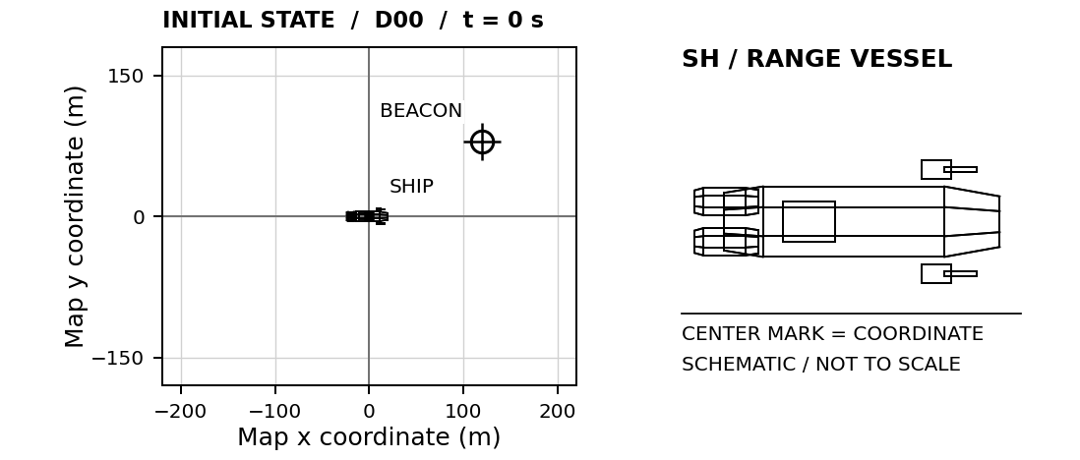
Ship at (0, 0) m with map velocity (10, −5) m/s. Stationary beacon at (120, 80) m. Check time: 4 s.

01 Required round map velocity
$v_{x} = \frac{120 m}{4 s}\text{ = 30 m/s ; }v_{y} = \frac{80 m}{4 s}\text{ = 20 m/s}$

02 Launch velocity relative to the ship
$v_{x}\text{ = 30 m/s − 10 m/s = 20 m/s}$
$v_{y}\text{ = 20 m/s − (−5 m/s) = 25 m/s}$
ENTER IN D00 Horizontal: 20 m/s Vertical: 25 m/s
Check the map frame: (20 + 10, 25 − 5) = (30, 20) m/s. After 4 s the round reaches (120, 80) m; the ship is at (40, −20) m.

03 Before the next check
Why is the vertical launcher setting greater than the round’s required vertical map velocity?

D01 / OPTIONAL SPECIALTY

Following current
CADET ____________________________ CLASS ______ DATE __________
Your ship coasts toward the beacon. Enter velocity relative to the ship; the simulator adds the ship's velocity once.
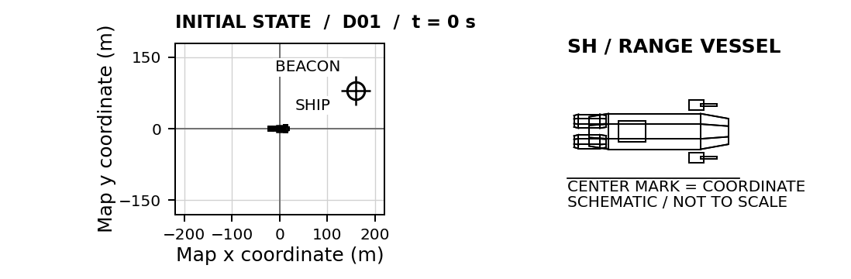
SHIP START (0, 0) m BEACON START (160, 80) m CHECK TIME 4 s
Ship map velocity (10, 0) m/s. Beacon map velocity (0, 0) m/s.
01 LAUNCH CALCULATION Find round map velocity, then subtract ship map velocity.
HORIZONTAL / x  G / U Givens and unknowns  E Equation before substitution  S / S Substitute and solve with units  $v_{x}\text{ = __________ m/s}$ | VERTICAL / y  G / U Givens and unknowns  E Equation before substitution  S / S Substitute and solve with units  $v_{y}\text{ = __________ m/s}$
SIMULATOR CHECK Best miss: ______ m □ Verified □ Retry Attempt: ______
EXPLAIN How much horizontal map velocity does the ship contribute to the round?

D02 / OPTIONAL SPECIALTY

Crossing drift
CADET ____________________________ CLASS ______ DATE __________
Account for the ship's nonzero starting position and its motion along both axes. The launch occurs at t = 0 s.
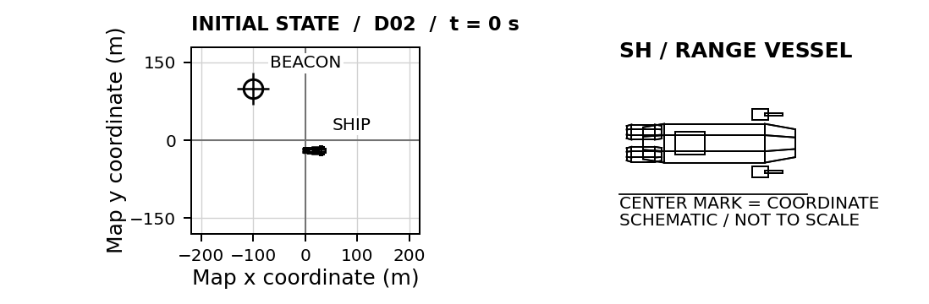
SHIP START (20, -20) m BEACON START (-100, 100) m CHECK TIME 6 s
Ship map velocity (-5, 10) m/s. Beacon map velocity (0, 0) m/s.
01 LAUNCH CALCULATION Find round map velocity, then subtract ship map velocity.
HORIZONTAL / x  G / U Givens and unknowns  E Equation before substitution  S / S Substitute and solve with units  $v_{x}\text{ = __________ m/s}$ | VERTICAL / y  G / U Givens and unknowns  E Equation before substitution  S / S Substitute and solve with units  $v_{y}\text{ = __________ m/s}$
SIMULATOR CHECK Best miss: ______ m □ Verified □ Retry Attempt: ______
EXPLAIN Explain the distinction between the round's map velocity and its launch velocity relative to the ship.

D03 / OPTIONAL SPECIALTY

Two moving vessels
CADET ____________________________ CLASS ______ DATE __________
Predict the moving beacon's coordinates at 5 s. Enter your prediction to place its ghost marker, then calculate the launcher settings. The ghost shows your prediction only.
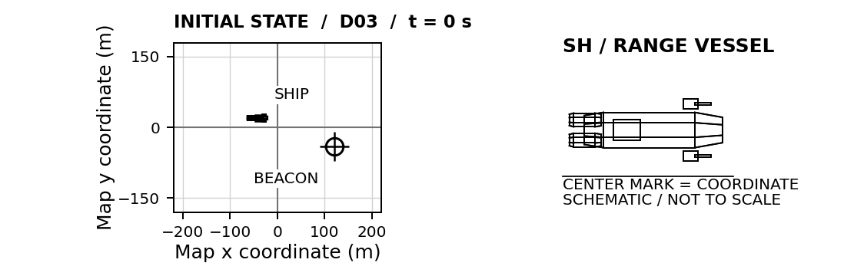
SHIP START (-40, 20) m BEACON START (120, -40) m CHECK TIME 5 s
Ship map velocity (8, -6) m/s. Beacon map velocity (-2, 4) m/s.
PREDICTED BEACON AT CHECK TIME (__________, __________) m
01 LAUNCH CALCULATION Find round map velocity, then subtract ship map velocity.
HORIZONTAL / x  G / U Givens and unknowns  E Equation before substitution  S / S Substitute and solve with units  $v_{x}\text{ = __________ m/s}$ | VERTICAL / y  G / U Givens and unknowns  E Equation before substitution  S / S Substitute and solve with units  $v_{y}\text{ = __________ m/s}$
SIMULATOR CHECK Best miss: ______ m □ Verified □ Retry Attempt: ______
EXPLAIN Explain why aiming at the beacon's initial position fails, even with the correct ship-velocity correction.

