TRN 02 / REQUIRED CERTIFICATION

Motion Graphs
CADET ____________________________ CLASS ______ DATE __________
A moving beacon sends a motion trace to your console. Interpret the graph, predict its position at the check time, then calculate a round that meets it there. Complete Basic Range first.

01 Reference table equations
$\overline{v} = \frac{d}{t} = \frac{v_{f} + v_{i}}{2}$
$a = \frac{Δv}{t} = \frac{v_{f} − v_{i}}{t}$
$v_{f} = v_{i} + at$
$d = v_{i}t + \frac{1}{2}at^{2}$
Reference: NYSED Physics Reference Tables, 2025 edition, p. 2. The endpoint-average form assumes uniform acceleration. Apply constant-acceleration equations separately to each suitable interval.
The bar means average. Subscripts i and f mean initial and final. Δ means change. The added x and y subscripts identify components. Graphs show only the beacon’s horizontal motion.

02 Read the axes before calculating
Graph | Slope | Signed area
Displacement vs time | Velocity | Not used here
Velocity vs time | Acceleration | Displacement
Acceleration vs time | Not used here | Change in velocity
These graph rules are derived relationships. A horizontal displacement-time line means rest. A horizontal velocity-time line means constant velocity, which may be nonzero.
Area below zero on a velocity-time graph is negative displacement. Add area magnitudes to obtain total distance. On an acceleration-time graph, area gives a change in velocity, not displacement.

03 Qualification sequence
G01: slope and direction. G02: signed area. G03: distance and displacement. G04: acceleration and reversal. G05: acceleration to velocity to position.
For every G check, enter the requested graph reading, predicted beacon coordinates, and round launch velocities. The prediction marker displays your estimate. It does not reveal the correct answer.
Use the table of graph points in the console when needed. Read, calculate, then test. The ship and round do not accelerate in this course.
G00 / WORKED TELEMETRY CHECK

Reading the trace
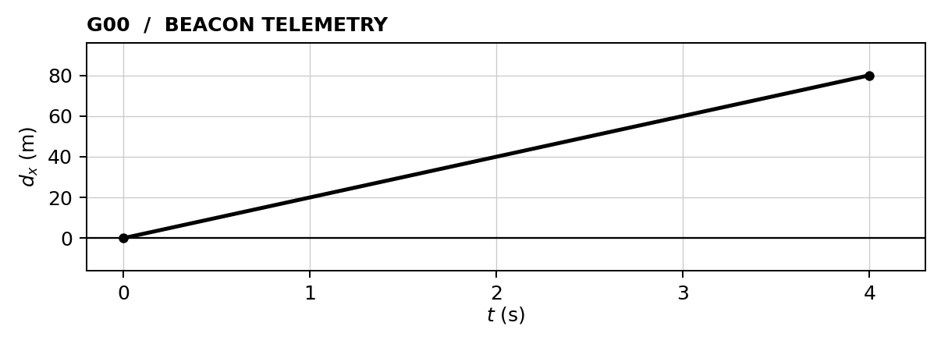
The ship starts at (0, 0) m. The beacon starts at (40, 40) m. Its displacement is measured from its own starting point, so the graph begins at zero.

01 Read the beacon velocity and displacement
$v_{x} = \frac{80 m − 0 m}{4 s − 0 s}\text{ = +20 m/s (beacon)}$
The beacon moves +80 m horizontally in 4 s. Final beacon coordinates: (40 + 80, 40) = (120, 40) m. Its vertical coordinate stays fixed.

02 Calculate the round velocity
$v_{x} = \frac{120 m − 0 m}{4 s}\text{ = +30 m/s}$
$v_{y} = \frac{40 m − 0 m}{4 s}\text{ = +10 m/s}$
ENTER IN G00 Graph reading: 20 m/s
Beacon prediction: (120, 40) m Launcher: (30, 10) m/s

03 Read a flat trace
Quick paper check: If a displacement-time trace stays at +20 m from 2 s to 5 s, what is the velocity during that interval? Explain without dividing the graph height by the elapsed time.

G01 / REQUIRED FLIGHT CHECK

A descending trace
CADET ____________________________ CLASS ______ DATE __________
Read the slope of the displacement–time graph. Find the beacon’s signed horizontal velocity, predict its coordinates at 4 s, and intercept it. Vertical motion is zero.
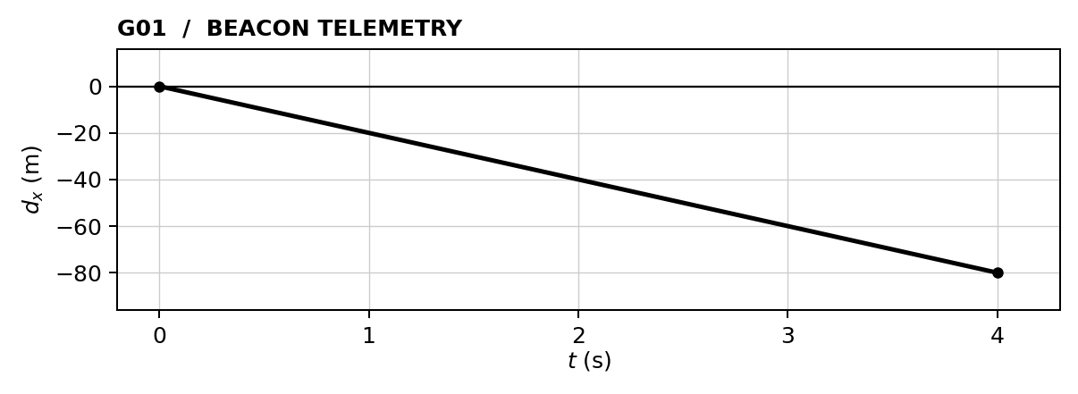
SHIP START (0, 0) m BEACON START (160, 80) m CHECK TIME 4 s
Ship stationary. Beacon moves horizontally only; its y coordinate stays fixed.
01 GRAPH READING Horizontal beacon velocity = __________ m/s
Show the slope or area calculation. Then find signed horizontal displacement.

$d_{x}\text{ = ______ m (beacon)}$
PREDICTED BEACON AT CHECK TIME (__________, __________) m
02 LAUNCH CALCULATION Use displacement from the ship to the final beacon position.
HORIZONTAL / x  G / U Givens and unknowns  E Equation before substitution  S / S Substitute and solve with units  $v_{x}\text{ = __________ m/s}$ | VERTICAL / y  G / U Givens and unknowns  E Equation before substitution  S / S Substitute and solve with units  $v_{y}\text{ = __________ m/s}$
SIMULATOR CHECK Best miss: ______ m □ Verified □ Retry Attempt: ______
EXPLAIN What does a downward-sloping displacement–time line tell you about direction?

G02 / REQUIRED FLIGHT CHECK

Area is a journey
CADET ____________________________ CLASS ______ DATE __________
Read the area under the velocity–time graph from 0 to 6 s. Add that displacement to the beacon’s initial x coordinate. Its y coordinate stays fixed.
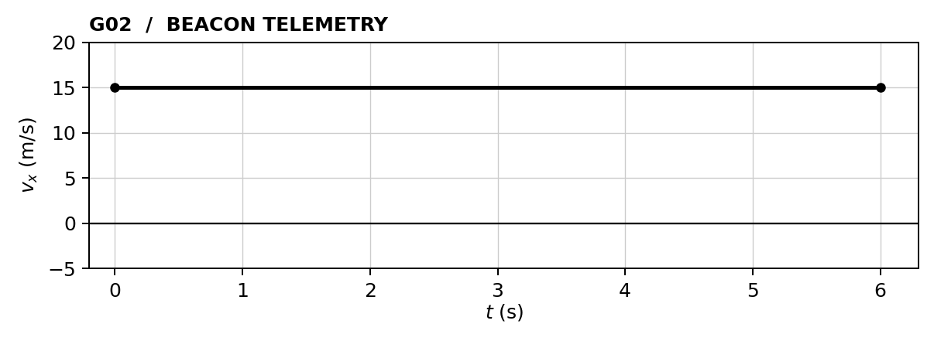
SHIP START (0, 0) m BEACON START (-60, 60) m CHECK TIME 6 s
Ship stationary. Beacon moves horizontally only; its y coordinate stays fixed.
01 GRAPH READING Horizontal beacon displacement = __________ m
Show the slope or area calculation. Then find signed horizontal displacement.

$d_{x}\text{ = ______ m (beacon)}$
PREDICTED BEACON AT CHECK TIME (__________, __________) m
02 LAUNCH CALCULATION Use displacement from the ship to the final beacon position.
HORIZONTAL / x  G / U Givens and unknowns  E Equation before substitution  S / S Substitute and solve with units  $v_{x}\text{ = __________ m/s}$ | VERTICAL / y  G / U Givens and unknowns  E Equation before substitution  S / S Substitute and solve with units  $v_{y}\text{ = __________ m/s}$
SIMULATOR CHECK Best miss: ______ m □ Verified □ Retry Attempt: ______
EXPLAIN Why does the area under this graph have units of meters rather than meters per second?

G03 / REQUIRED FLIGHT CHECK

Reversal protocol
CADET ____________________________ CLASS ______ DATE __________
The beacon reverses at 3 s. Find its total distance traveled, then use signed displacement to predict its final position. The instantaneous velocity change is an idealized training maneuver.
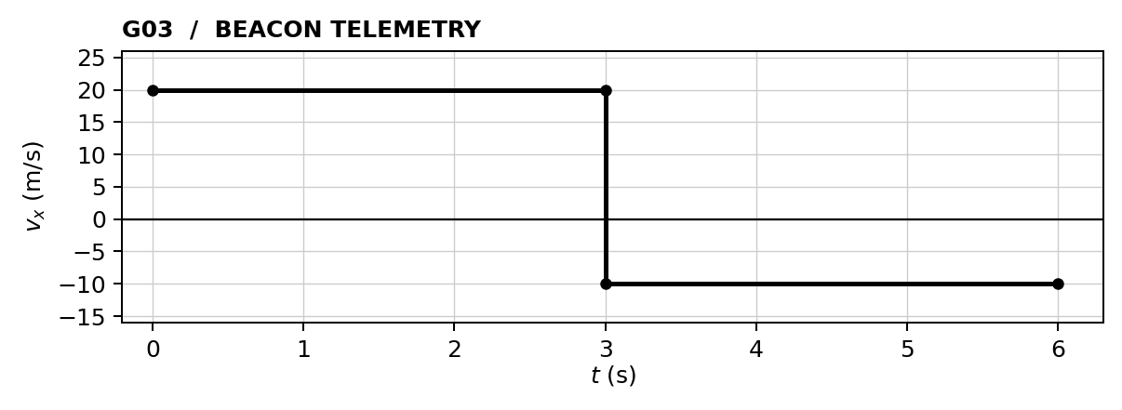
SHIP START (0, 0) m BEACON START (60, -60) m CHECK TIME 6 s
Ship stationary. Beacon moves horizontally only; its y coordinate stays fixed.
01 GRAPH READING Total horizontal distance traveled = __________ m
Show the slope or area calculation. Then find signed horizontal displacement.

$d_{x}\text{ = ______ m (beacon)}$
PREDICTED BEACON AT CHECK TIME (__________, __________) m
02 LAUNCH CALCULATION Use displacement from the ship to the final beacon position.
HORIZONTAL / x  G / U Givens and unknowns  E Equation before substitution  S / S Substitute and solve with units  $v_{x}\text{ = __________ m/s}$ | VERTICAL / y  G / U Givens and unknowns  E Equation before substitution  S / S Substitute and solve with units  $v_{y}\text{ = __________ m/s}$
SIMULATOR CHECK Best miss: ______ m □ Verified □ Retry Attempt: ______
EXPLAIN Explain why the total distance traveled is greater than the magnitude of the displacement.

G04 / REQUIRED FLIGHT CHECK

An accelerating contact
CADET ____________________________ CLASS ______ DATE __________
The beacon accelerates uniformly. Read acceleration from the slope and displacement from signed area. Predict the beacon’s position at 4 s. The launched round still coasts at constant velocity.
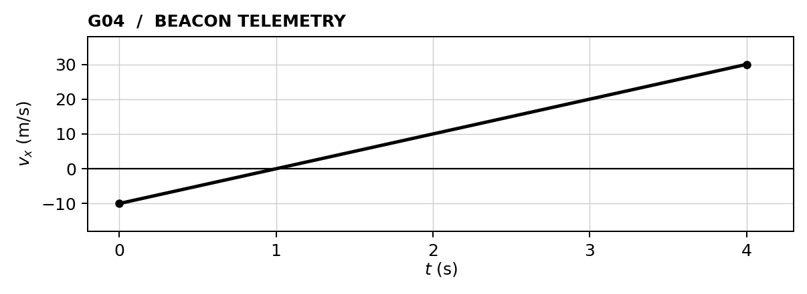
SHIP START (0, 0) m BEACON START (80, 80) m CHECK TIME 4 s
Ship stationary. Beacon moves horizontally only; its y coordinate stays fixed.
01 GRAPH READING Horizontal beacon acceleration = __________ m/s²
Show the slope or area calculation. Then find signed horizontal displacement.

$d_{x}\text{ = ______ m (beacon)}$
PREDICTED BEACON AT CHECK TIME (__________, __________) m
02 LAUNCH CALCULATION Use displacement from the ship to the final beacon position.
HORIZONTAL / x  G / U Givens and unknowns  E Equation before substitution  S / S Substitute and solve with units  $v_{x}\text{ = __________ m/s}$ | VERTICAL / y  G / U Givens and unknowns  E Equation before substitution  S / S Substitute and solve with units  $v_{y}\text{ = __________ m/s}$
SIMULATOR CHECK Best miss: ______ m □ Verified □ Retry Attempt: ______
EXPLAIN When does the beacon reverse direction? Why is the area below zero subtracted?

G05 / REQUIRED FLIGHT CHECK

From acceleration to position
CADET ____________________________ CLASS ______ DATE __________
The beacon’s initial horizontal velocity is +10 m/s. Use the acceleration graph to find its final velocity and displacement over 4 s. Its vertical velocity is zero.
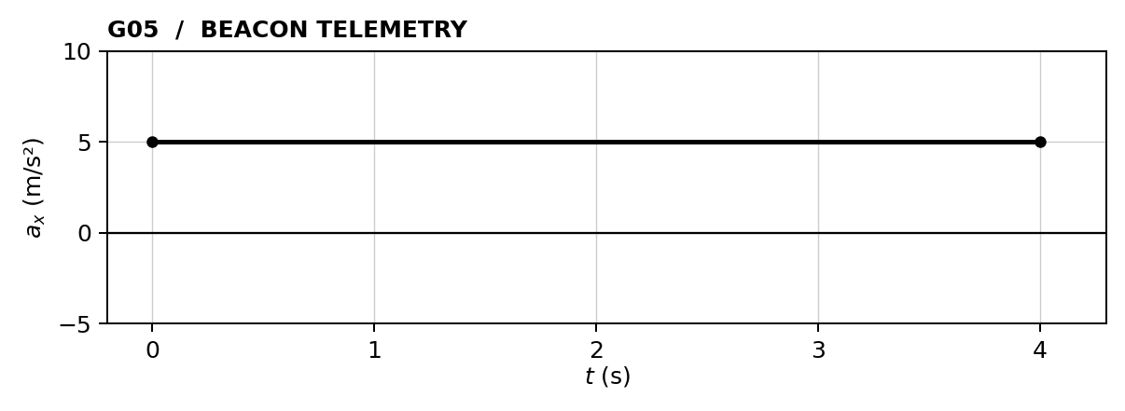
SHIP START (0, 0) m BEACON START (-80, 60) m CHECK TIME 4 s
Ship stationary. Beacon moves horizontally only; its y coordinate stays fixed.
01 GRAPH READING Final horizontal beacon velocity = __________ m/s
Show the slope or area calculation. Then find signed horizontal displacement.

$d_{x}\text{ = ______ m (beacon)}$
PREDICTED BEACON AT CHECK TIME (__________, __________) m
02 LAUNCH CALCULATION Use displacement from the ship to the final beacon position.
HORIZONTAL / x  G / U Givens and unknowns  E Equation before substitution  S / S Substitute and solve with units  $v_{x}\text{ = __________ m/s}$ | VERTICAL / y  G / U Givens and unknowns  E Equation before substitution  S / S Substitute and solve with units  $v_{y}\text{ = __________ m/s}$
SIMULATOR CHECK Best miss: ______ m □ Verified □ Retry Attempt: ______
EXPLAIN What does the area under an acceleration–time graph give you? How do you then find displacement?

